**Practical No – 1**

**Aim :- Visualization Plots Using R Tools.**

1. Histogram in R using mtcars data set

*hist(mtcars$mpg)*

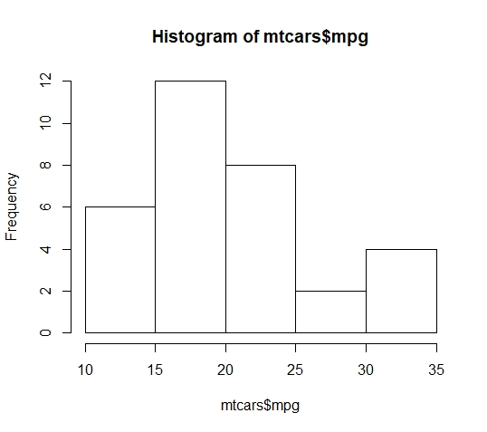

mtcars is the name of the dataset and mpg is the attribute

‘$’ is used for letting you know that mpg is present in mtcars.

hist is the command for histogram (no of bars in the histogram can be controlled & bars can be coloured)

1. *hist(mtcars$mpg, breaks=5, col="yellow")*

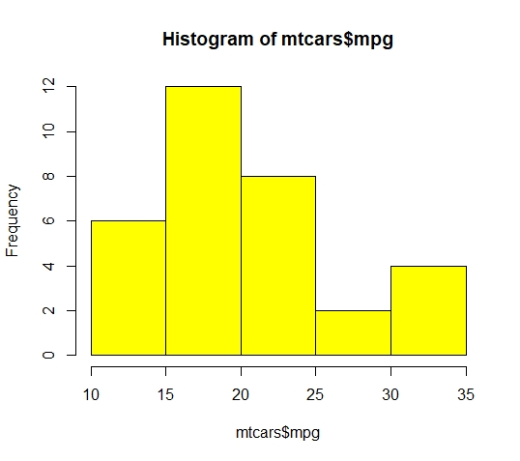

1. Simple bar plot from the dataset mtcars on the attributes

Gears.count is the variable name having that contains numerical values in the table.

Barplot is the function for barplot

*counts <- table(mtcars$gear)*

*print(counts)*

*barplot(counts, main= "Car Distribution", xlab= "Number of Gears", col="red")*



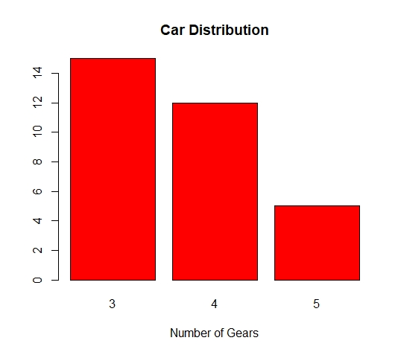

1. Simple Horzontal Bar plot with Added Labels

*Counts <- table(mtcars$gear)*

*barplot(Counts, main = "Car Distribution", horiz = TRUE, names.arg = c("3 Gears",'4 Gears','5 Gears'))*

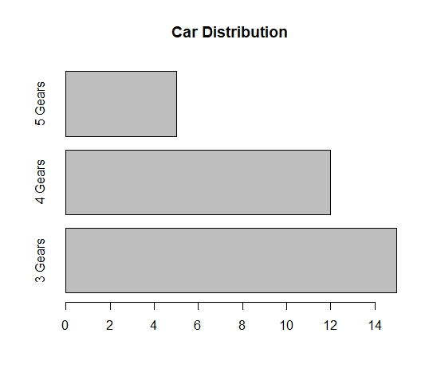

1. Stacked bar plot with colors& legend on mtcars dataset

Here gear and VS attributes are used

*counts <- table(mtcars$vs, mtcars$gear)*

*print(counts)*

*barplot(counts,main = "Car Distribution by gears & VS", xlab = "Number of Gear", col= c("yellow","red"), legend = rownames(counts))*

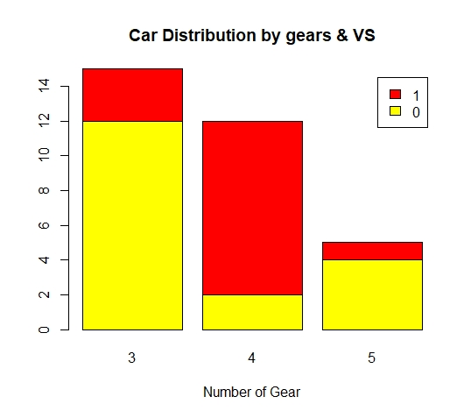

1. Grouped Bar Plot from mtcars dataset

*counts <- table(mtcars$vs, mtcars$gear)*

*barplot(counts,main = "Car Distribution by Gears and VS",xlab = "Number of gears", col = c("darkblue","red"), legend= rownames(counts),beside = TRUE)*

*print(mtcars)*

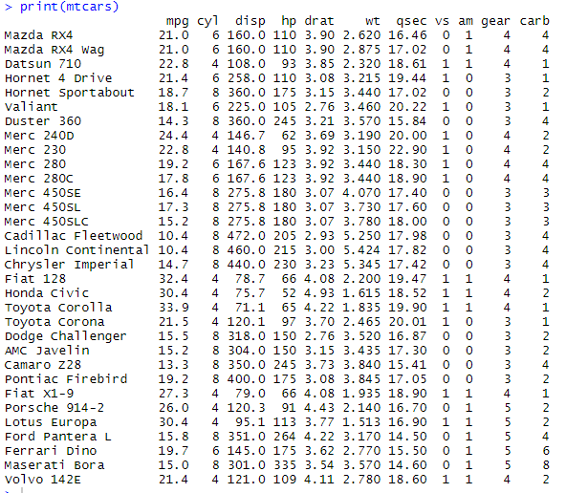

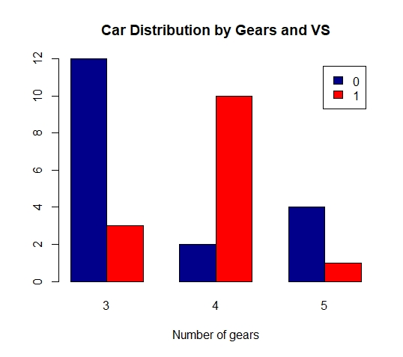

1. Simple Pie Chart

*l <-c(20,20,30,30)*

Pie has the values for the sizes

*label <-c("India","US","Dubai","France")*

Pie is the command for the pie chart

*pie(l, labels = label,main = "Pie Chart of Countries")*

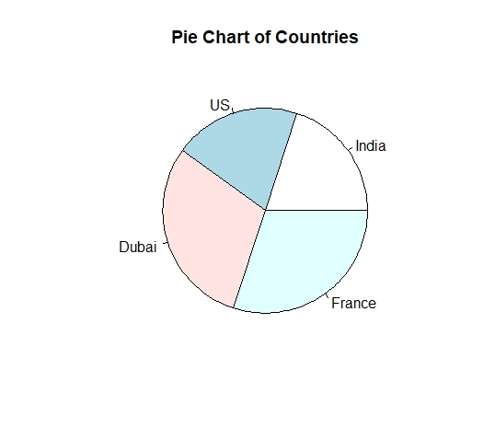

1. Pie Chart with Percentage

*l <- c(20,20,30,30)*

*label <-c("India","US","Dubai","France")*

*percentage<-round(l/sum(l)*100)*

Add percentage to labels

*label <- paste(label, percentage)*

Add % to labels

*label <- paste(label,"%", sep = "")*

*pie(l, labels = label,main = "Pie Chart of Countries with percentage", col = rainbow(length(label)))*

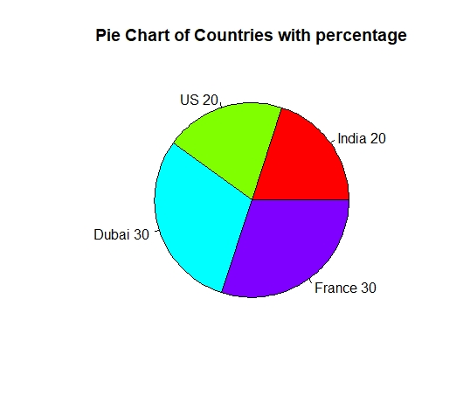

1. Box Plot

Box plot of MPG by Car Cylinders

*boxplot(mpg~cyl, data = mtcars, main = "Car Mileage Data", xlab = "Number of cylinders", ylab = "Miles Per Gallons", col="blue")*

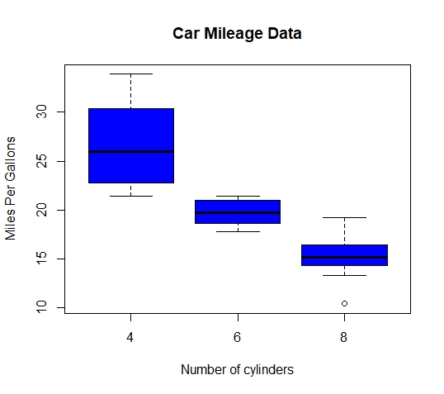

1. Scatter Plot from natcars dataset

*attach(mtcars)*

*plot(wt, mpg, main = "Scatter Plot Example", ylab = "Miles per gallons",xlab= "Car weight", pch = 19)*

